CS 499 3-2 Milestone Two
Jason Fuller - 1/25/2026

1. Briefly describe the artifact. What is it? When was it created?

The artifact selected for my Software Engineering and Design enhancement is a Python-based adventure video game originally developed in IT-140: Introduction to Scripting. In its initial form back from December 2023, the artifact was a console-driven game where the player navigates through connected rooms, collects items, and eventually encounters a final villain. The player’s success is determined by whether all required items have been collected before entering the final room.
In its original IT-140 version, the artifact was designed to reinforce foundational programming concepts such as conditional logic, loops, dictionaries, and simple function decomposition. While the code met the learning goals of an introductory course, it was also intentionally limited by being tightly coupled, minimally modular, and heavily dependent on hard-coded values and a fixed game map.
For CS-499, the artifact has been enhanced beyond the original console implementation into a more professional and extensible application. It has been refactored using Model-View-Controller (MVC) principles and expanded into a client/server-style design using a user interface layer and a backend control layer.
Before:
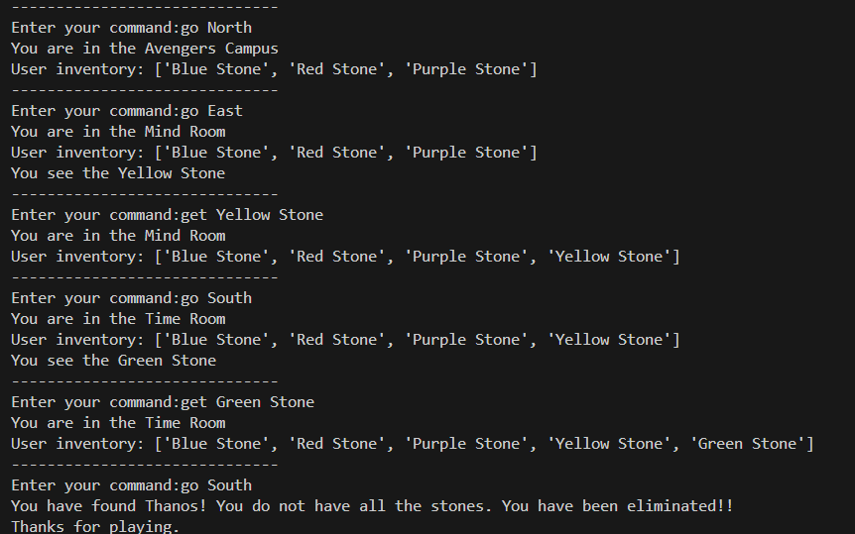

After:
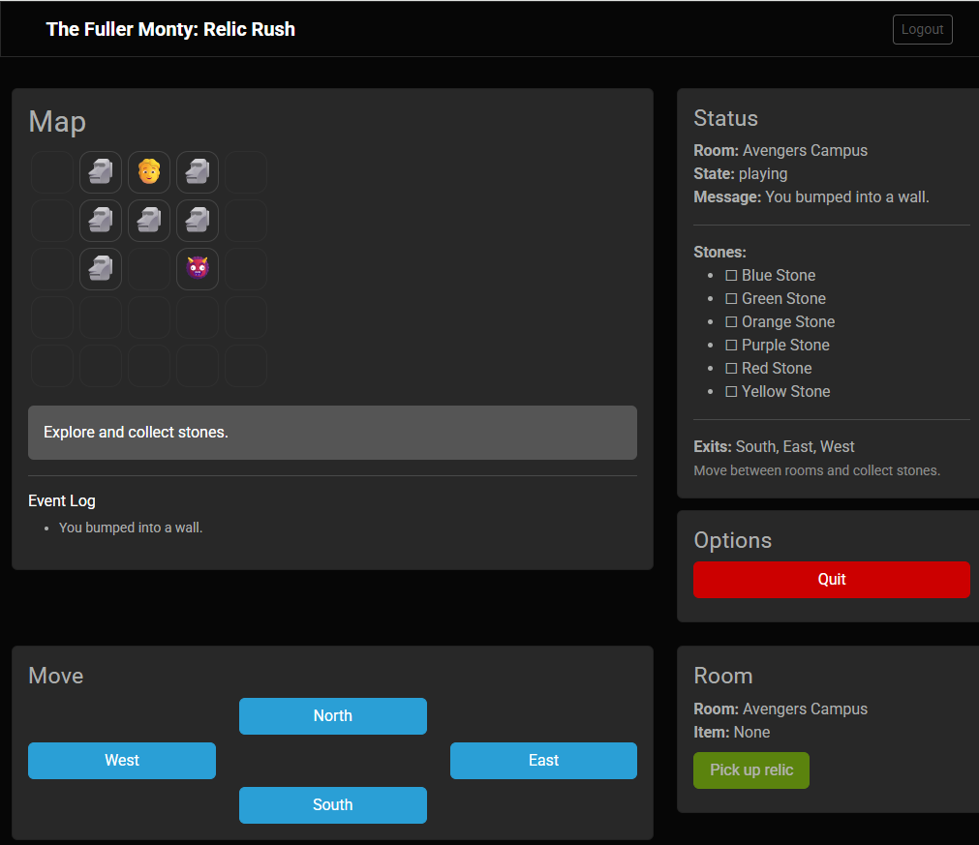

2. Justify the inclusion of the artifact in your ePortfolio. Why did you select this item? What specific components showcase your skills and abilities in software development? How was the artifact improved?

I selected this artifact for my ePortfolio because it provides a strong “before and after” comparison that clearly demonstrates growth from introductory scripting to a more professional software engineering approach. Many academic projects prove that functionality works, but this capstone allows me to demonstrate something employers value even more: the ability to take an existing solution, evaluate weaknesses, and rebuild it using practices that support scalability, maintainability, and real-world deployment.
This artifact also fits well in an ePortfolio because it highlights technical skills across multiple areas that employers commonly look for, including architecture, modular design, user authentication, secure configuration management, and deployment workflow practices. The enhanced version shows not only that I can write working code, but also that I can structure code in a way that is easier to understand, test, and extend over time.
The most significant improvement completed for this milestone was refactoring the application into an MVC architecture and moving the project away from the limitations of a single-file console script. In the enhanced version:
- The Model layer manages game state, including player location, inventory, and session context.
- The View layer provides a user-facing interface with a more modern interaction design than the original console output.
- The Controller layer coordinates control flow, validates actions, and enforces game rules in a centralized and maintainable way.
This separation of concerns is a major improvement over the original artifact because it reduces coupling and makes future enhancements, such as adding levels, expanding item logic, or improving validation, more realistic and less error-prone.
< I intend to add a flow chart showing MVC architecture >
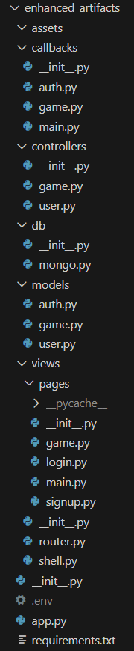
Beyond architecture, I also improved the artifact by integrating a working authentication system and real persistence infrastructure. The enhanced artifact now includes login and signup pages tied to MongoDB, which provides a stronger sense of a complete application rather than a standalone script. Additionally, I deployed the project using Render.com as a hosted web service, allowing the artifact to be demonstrated live rather than only through local execution. The application can be viewed at: https://relicrush.onrender.com. (Note that it may take a couple of minutes to spin up using the free tier)
This deployment also demonstrates modern workflow practices. I configured a CI/CD pipeline that pulls and deploys the latest code automatically whenever a commit is detected. The deployed service pulls from a synchronized repository copy instead of the full capstone repository so that unnecessary files are excluded and the deployment remains clean and maintainable.

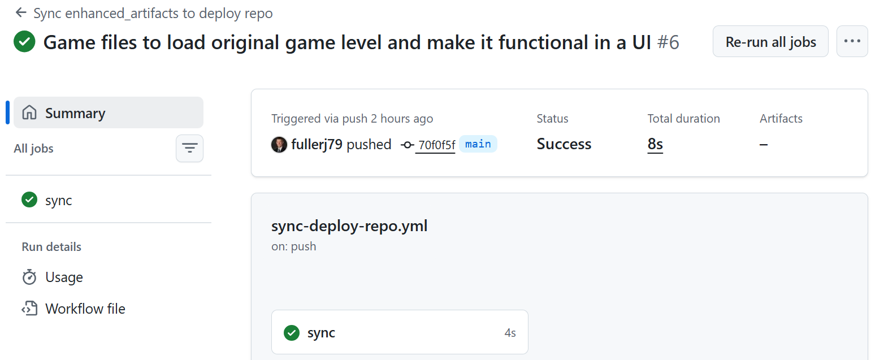

Security improvements were also included in the enhancement. Sensitive values such as the MongoDB URI, database name, and the pepper string used for password hashing are stored as secure environment variables rather than being hard-coded into source files. Render’s certificate support was also confirmed so the application runs using HTTPS, reinforcing safe communication patterns expected in modern web applications.
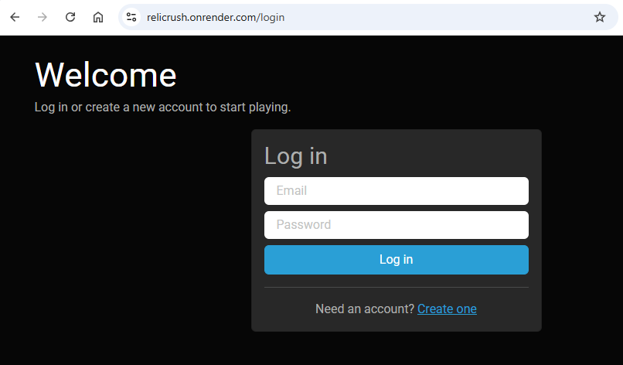
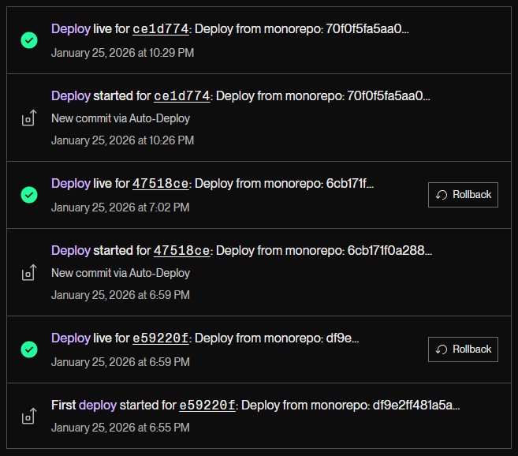

3. Did you meet the course outcomes you planned to meet with this enhancement in Module One? Do you have updates to your outcome-coverage plans?

The enhancement work completed for Milestone Two aligns strongly with the outcome coverage plans from Module One, and in several areas I exceeded what I originally anticipated. My enhancement plan emphasized architectural structure, maintainability, and a secure-first mindset, and the work completed so far demonstrates meaningful progress toward those outcomes.
Course Outcome Alignment
Outcome 4: Demonstrate an ability to use well-founded and innovative techniques, skills, and tools in computing practices to implement computer solutions that deliver value.
This milestone demonstrates Outcome 4 through the refactor into MVC, the adoption of modern UI interaction patterns, and the deployment of the application as a hosted service. Using a client-facing interface backed by structured server-side logic reflects a more industry-aligned approach than a console application and highlights professional software engineering practices.
Outcome 5: Develop a security mindset that anticipates adversarial exploits and mitigates vulnerabilities to protect resources and data.
This outcome is strongly represented in this milestone through multiple security improvements. I created a MongoDB Atlas database using least-privilege credentials, restricted access using CIDR allow lists (limited to my development workstation and Render workspace), and enforced TLS connections. I also protected sensitive configurations through environment variables, including database connection settings and the pepper string used for password hashing. Finally, I verified HTTPS support through Render’s certificate usage, reinforcing encrypted communication for authentication and gameplay interactions.
Outcome 2: Design, develop, and deliver professional-quality oral, written, and visual communications.
This outcome is supported through improvements in how the artifact is presented and communicated. The UI provides clearer user interaction than the console, and I have begun formatting the ePortfolio itself using HTML and CSS to present content in a more visually polished and professional way. While some visual bugs remain, this represents major progress in portfolio presentation quality.
Outcome 1: Employ strategies for building collaborative environments that enable diverse audiences to support decision making.
The MVC refactor also supports this outcome by producing a codebase that is easier to interpret and collaborate on. Separating responsibilities across layers makes it easier for another developer, or a reviewer, to understand the structure quickly, identify where changes belong, and maintain the system without impacting unrelated components.
Updates to Outcome Coverage Plans
One adjustment to my original outcome plan is that I ended up completing more practical deployment and security work in this milestone than I initially expected. The original enhancement plan emphasized HTTPS configuration through Flask SSL context primarily as a demonstration, but using Render’s managed certificates provided a more realistic and production-aligned HTTPS solution. In addition, implementing CI/CD and deploying the system as a live service strengthened the professional readiness of the artifact beyond purely architectural refactoring.
The remaining outcome coverage plan stays consistent: the next priority is completing Category Two improvements, addressing validation and defensive logic more thoroughly, and improving the maintainability gaps such as hard-coded values that still exist in places throughout the refactored structure.

4. Reflect on the process of enhancing and modifying the artifact. What did you learn? What challenges did you face?

Enhancing this artifact provided a clear lesson in the difference between writing code that works and engineering software that can be maintained, deployed, and extended. The MVC refactor forced me to think in terms of structure first, where responsibilities belong, how state should be managed, and how the user interface should communicate with the backend logic. This process reinforced that professional-level development is often less about new features and more about creating design clarity that makes future changes safer and faster.
One of the most valuable things I learned was how architectural decisions directly affect maintainability and scalability. Refactoring from a console script into an MVC design required reshaping the project into modular pieces, which improved readability and reduced tight coupling. At the same time, it revealed the importance of consistent organization and documentation. If structure is improved but documentation is inconsistent, the codebase still becomes harder to work with as complexity increases.
I also gained experience implementing and validating secure development practices. Setting up MongoDB Atlas with least privilege and CIDR restrictions reinforced the importance of controlling access at the network level, while environment variables ensured that secrets were not embedded in source code. Confirming TLS enforcement and HTTPS deployment also reinforced that security is most effective when it is designed into the system early rather than added later.
The largest challenge I faced was that the MVC refactor and UI integration required significantly more effort than I originally anticipated. Moving from a single-file console game into a layered system meant debugging integration points, reorganizing code responsibilities, and ensuring that user workflows still functioned correctly. Because of the scope of this refactor, I did not have as much time as I wanted for fully structured comments and consistent defensive testing. I also identified bugs and hard-coded values that remain in the project, which will be addressed as I continue enhancing Category Two improvements.
In addition, I spent time formatting my ePortfolio using HTML and CSS. This was a major step toward presenting my work professionally and creatively, but it introduced new design challenges such as layout bugs and visual polish requirements. Even with those issues, the process was valuable because it helped reinforce the reality that “presentation matters” when the goal is self-promotion and employer-facing documentation.
Overall, this milestone helped me connect academic work to professional expectations. It is one thing to complete a class project, but it is another to improve it in ways that demonstrate architecture, security, workflow, and deployment readiness. The enhancement process made it clear that delivering value in software engineering requires both functionality and professional quality.

